**5. Cross validation & Hyperparameter Tuning**

1. **Python 파일 다운 받기(**[**preamble.py**](https://github.com/amueller/introduction_to_ml_with_python/blob/main/preamble.py)**)**
2. **쥬피터 노트북 받기(**[**05-model-evaluation-and-improvement.ipynb**](https://github.com/amueller/introduction_to_ml_with_python/blob/main/05-model-evaluation-and-improvement.ipynb)**)**
3. **Study with book (**[**introduction-to-machine-learning-with-python-a-guide-for-data-scientists-9781449369415.html**](https://dokumen.pub/introduction-to-machine-learning-with-python-a-guide-for-data-scientists-9781449369415.html)**)**

* **Github address :** [**https://github.com/amueller/introduction_to_ml_with_python**](https://github.com/amueller/introduction_to_ml_with_python)
* 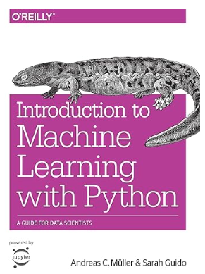 **Chapter 5.**